Step 1 : Create the packages for
Controller
Service
Repository
Entity
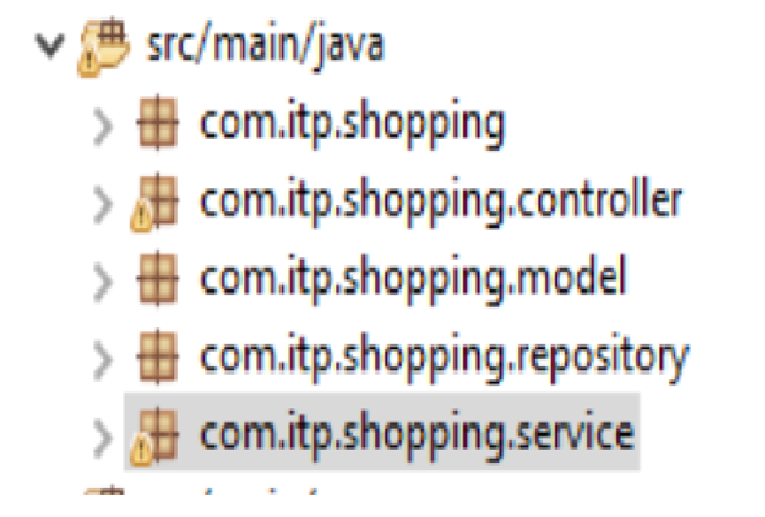
NOTE : please make them as sub packages of your main package which we have provided in spring initializr

Step 2: Configure the application.properties file in the resources folder
spring.application.name=MyFirstSpringboot
server.port=8083
spring.datasource.driver-class-name=com.mysql.jdbc.Driver
spring.datasource.url=jdbc:mysql://localhost:3306/firstspringbootdb
spring.datasource.username=root
spring.datasource.password=
spring.jpa.hibernate.ddl-auto=update

NOTE : firstspringbootdb should be created in MYSQL

Step 3 : in the controller package make the controller class
@RestController
public class MyController
{

}

Step 4 : make a endpoint in the controller class
@RequestMapping("/welcome")
public String welcome()
{
return "Welcome to Springboot";
}

Step 5 : save, project clean
Step 6: stop all previously running application
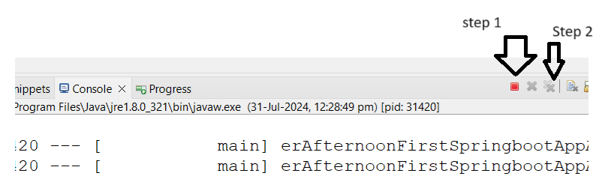
Step 7 : Restart your application from the main class
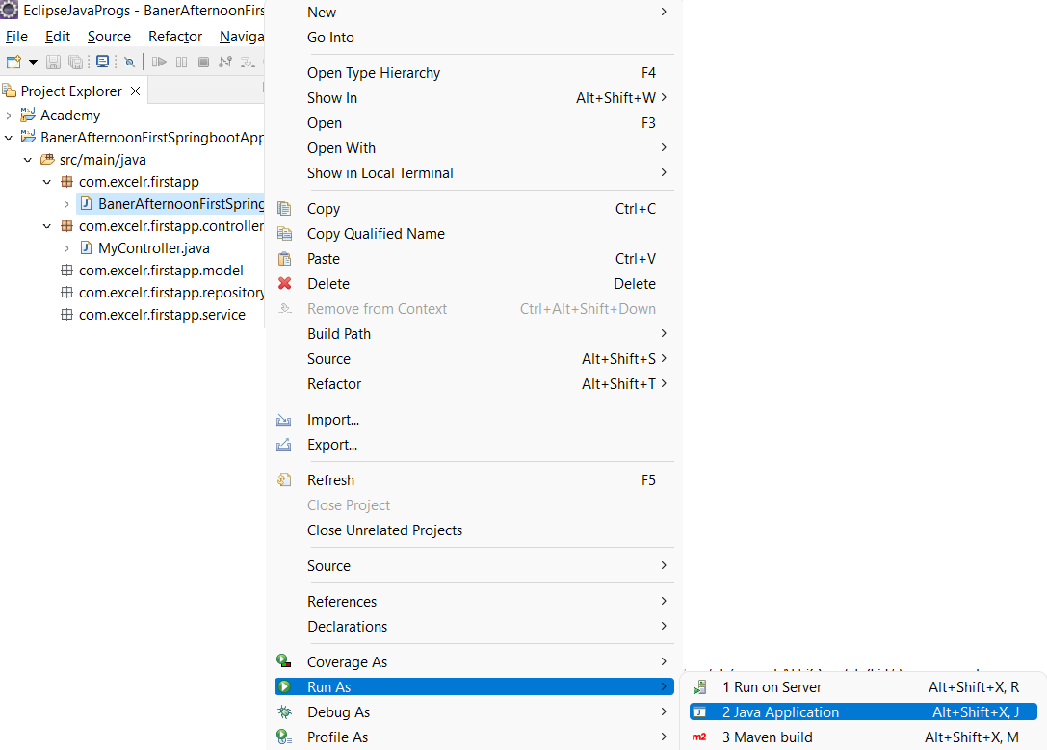
Step 8 : Open Browser
In the url type localhost:8085/welcome

